SUMMER SCHOOL LITERA SUMMER CENTRE MELLUZI
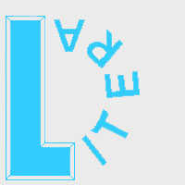 For students 7-18 years old

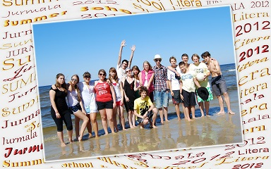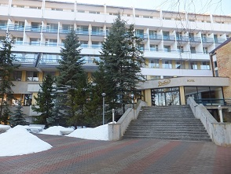

Main points:  - Accommodation in the hotel Daina at sea (twin rooms)  - Meals 4 times a day  - 25 × 45 min lessons a week  - Class sizes from 10 -14  - All levels of a foreign language  - Supervised activities every afternoon and evening  - All teaching materials and textbooks included  - 2 evening discos a week  - Professional help of a tutor every 24 hours a day  - Help of an organiser to arrange optional and personal activities  - Organisation of excursions for foreign students | Centre Melluzi  Every summer Language Centre LITERA organizes summer programmes for studies and rest at sea.  Summer School LITERA hires the hotel Daina which is situated in a picturesque place of Jurmala near the station Melluzi, only 200 metres from the sea.  Students live in twin rooms in a hotel at sea.  At Summer School LITERA students benefit from all the language advantages of learning English, German, Spanish and French whilst being able to enjoy all the fun of the seaside.  A various sportive and cultural programme: all sorts of parties, games and fun, sport competitions, beach games, drama performances, discos and talents’ show, quizzes, team presentation, comedy show and many others.
Sports included in fees: Football, Volleyball, Novuss, Olympic Games, Active Beach Games.
Extra activities: English Drama Club, Photo Session, Dancing Club, Video & Music Producing.
Smoking and alcohol are strongly forbidden.
SUMMER SCHOOL LITERA Typical Day at Summer School LITERA
Centre Melluzi

7:40 Waking up  7:50 Morning exercises  8:30 Breakfast: a great choice  9:00 – 10:30 1 & 2 lessons of a foreign language  10:30 – 11:00 Brunch  11:00 – 12:30 3 & 4 lessons of a foreign language  12:30 – 12:45 Break  12:45 – 13:30 5 lesson (Special course)  13:30 – 14:00 Lunch  14:00 – 15:00 Rest (Free time)  15:00 – 18:00 Afternoon activities: beach, sport, games & fun, preparation for parties  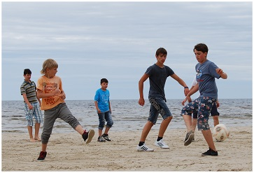  18:30 – 19:15 Dinner  20:00 – 22:00 Evening activities, extra activities, discos  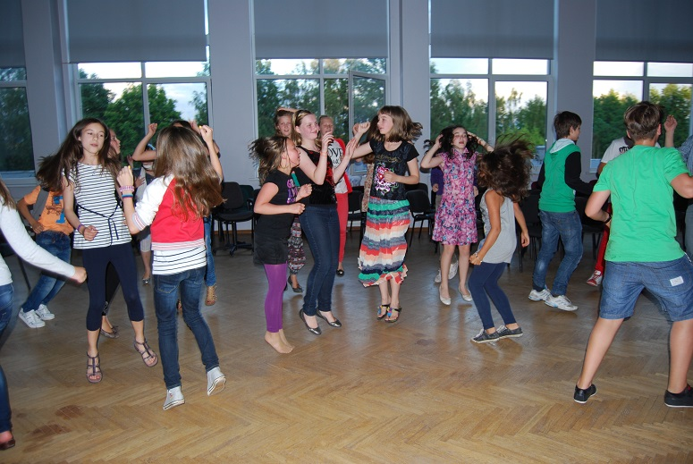  22:00 – 23:00 Sleep | Afternoon activities  There is something organized every afternoon including funny starts, treasure hunt, beach games, sand castles, football match, volleyball.  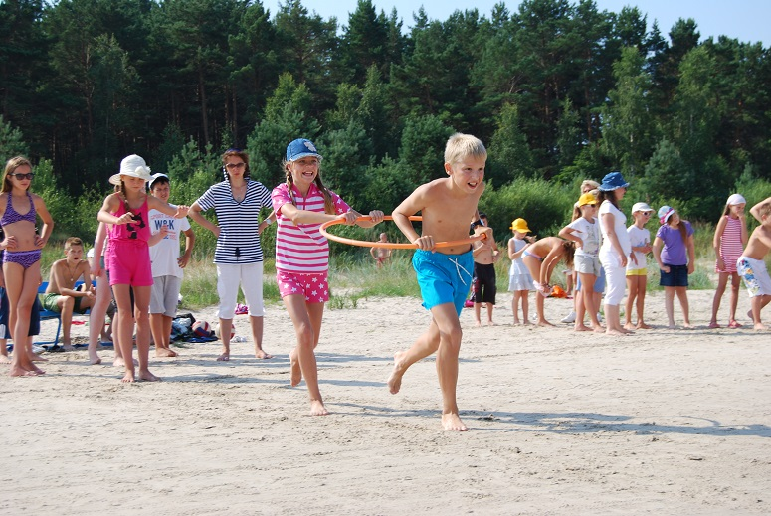  Evening activities and discos  Special attention is drawn to parties and discos. Every session has its own topic so that students can enjoy the variety of events: welcome party, team presentation, talents’ show, carnival, safari party, Hawaii party, the Day of Neptune, Disney Parade, discos and many others.  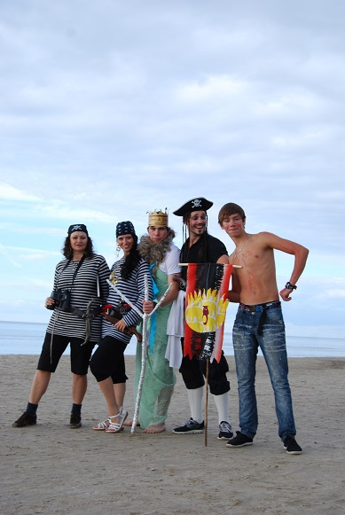  Excursions  Excursions around Latvia for foreign students may be arranged for a small charge.  Language Centre LITERA  Tel +371 29233800, +371 29128652 +371 67393104  e-mail: litera@mailbox.riga.lv  www.litera.lv

